University Senate Agenda
February 3, 2017, 2:00-3:15 in Rowan Auditorium

2:00-2:15

- Approval of agenda
- Introduction of visitors
- Approval of minutes from December meeting
- President’s report
  - New Director of Career Advancement: Bob Bullard
  - Diversity in hiring:
http://www.philly.com/philly/education/Diversity_at_colleges_Not_at_the_front
_of_classroom.html
  - Move from Linden targeted to be completed by end of Spring Break
  - Discussion of full-time, tenure-track faculty
  - RFP for applicant tracking software
  - Update on buildings
  - Next Full Senate meeting: Friday, March 3 at CMSRU
  - Please take the tobacco-free campus survey:
https://rowan.co1.qualtrics.com/SE/?SID=SV_6PBPxVTJNojLdEF

2:15-3:05

- Parental Leave Task Force (page 2)
- Second reading: Proposed changes to Registrar’s policies and procedures
(page 3 – Beki Golihur, the Registrar, will answer questions and concerns)
- Curriculum report (Marci Carrasquillo, page 12)

3:05-3:15

- Old business
- New business

Parental Leave Senate Task Force

Description of Charge: The ultimate goal of the task force is to recommend a parental leave policy for tenure track and tenured faculty to replace current practices and better meet the needs of faculty. To do this, the task force should assess existing inconsistencies in how parental leave is taken, investigate the policies of peer and aspirant institutions, and determine potential benefits and costs to the university. The task force should also coordinate with the union to ensure that recommendations align with all applicable labor agreements and law.

Committee Makeup: A group of 8-10 members who are diverse with respect to gender, tenure status, and childcare experiences (especially including experience with Rowan’s maternity/family leave). The committee will include Bob Zazzali, Senior Vice President, Community & Economic Development; Eileen Scott, Associate Vice President for Employee & Labor Relations; and at least one AFT representative.

Suggested Timeline: Group will be convened by February 1, 2017. Report of findings by December 1, 2017.

Recommended Updates from the Registrar and the Registrar Academic Board (RAB) to Existing Registration-related Policy
As of 04/22/16 – DRAFT – updated 10/2016 by request – SEE COMMENTS FOR UPDATES

Rationale for Updates to Existing Registration Policy
As of January 4, 2016, the Registrar’s Office and the Registrar’s advising board, RAB, have been charged by the Provost’s Office to assess and evaluate registration-related policies, practices, and processes, to ensure that they:
- are fairly and consistently administered across campus, regardless of academic program or college;
- are compliant with recent Financial Aid audit-related findings;
- are up to date and easily found; (For example, currently, several differing versions of registrationrelated policy are found on many locations throughout the web.)
- are student-centered, serving our current student population in the best possible ways, taking into account changes in that population such as online and off-site students, our office’s shift to include graduate students, and the addition of Rowan Global’s multiple Parts of Term and drop/add sessions;
- written policy and office practice align, and that any changes therein are well-communicated to students, faculty, and staff. (For example, no policy or form allows advisor signatures for overrides, registration, etc.; however, there has been a significant shift in the way advisors function on this campus and, based upon the desires of many academic departments, it had been the practice of the Registrar’s Office to accept advising signatures.)

RAB Board Members
- One representative from the Dean’s Office of the College of Communication & Creative Arts: Olga Vilceanu
- One representative from the Dean’s Office of the College of Business: Margaret Van Brunt
- One representative from the Dean’s Office of the College of Engineering: Steve Chin/Maria Perez-Colon
- One representative from the Dean’s Office of the College of Science & Mathematics: Eve Sledjeski
- One representative from the Dean’s Office of the College of Performing Arts: Melanie Stewart
- One representative from the Dean’s Office of the College of Education: Lisa VernonDotson/Beth Wassell
- One representative from the Dean’s Office of the College of Humanities & Social Sciences: Stephen Fleming/Larry Butler
- One representative from the Honor’s College: Kristen diNovi
- One representative from GSBS: Diane Worrad
- One representative from Rowan Global: Kelly Yanek/Georg Watt/Marie Dionosi
- One to three representatives (as needed) from SEM/Advising: Lori Getler and Beth Rey
- One representative from Student Life/Orientation: Drew Tinnin
- One representative from University Scheduling: Steve Kessel
- One representative from ASA: Jeffrey Fields
- One representative from the Senate Academic Policies & Procedures Committee: Mike Grove/Eddie Guerra
- Rebecca Gollihur, University Registrar or designee, which will often be Melissa McKenna

Update Plan/Goals
• Part III of this document is our recommended set of updated registration-related policies that we are asking to be reviewed and approved by the Provost’s Office (and AP&P/the Senate if needed).
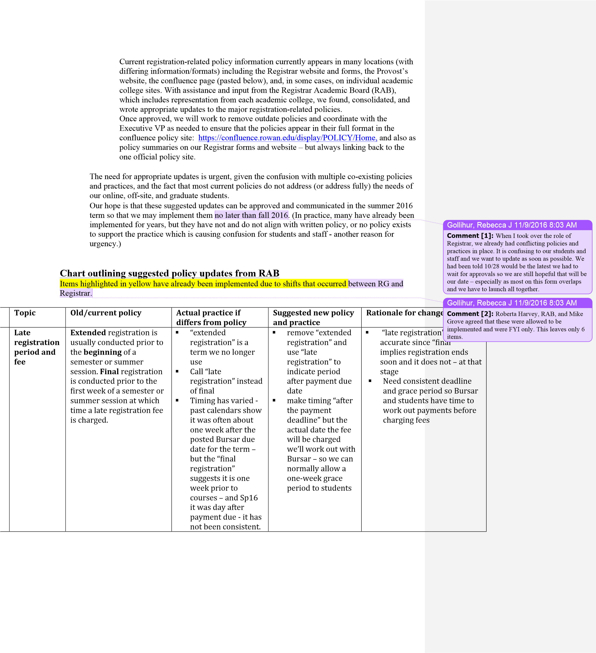
o
o

Timeline for Updates
•
•

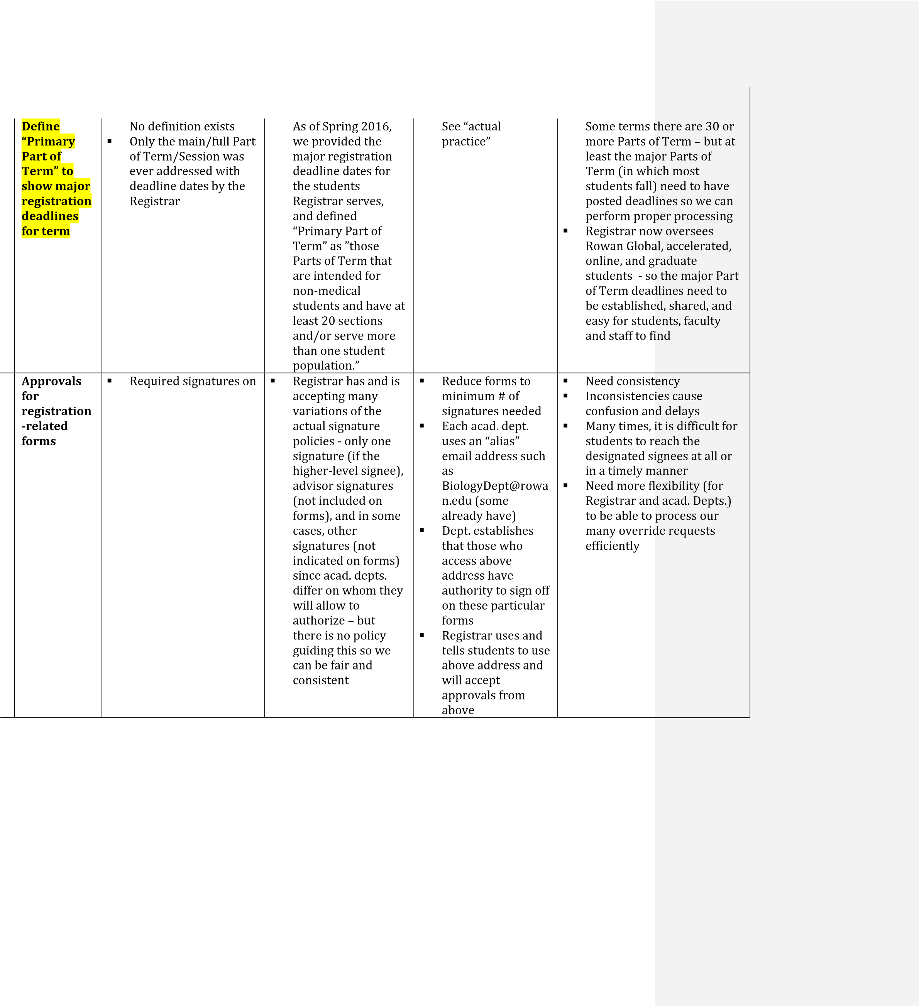
forms vary ( a few are outlined below): o Pre-req: instructor and chair
- P/NC: instructor o Duplicate Crse.
Waiver: chair o Course repeat: chair
- Hardship Withdrawal: instructor, chair, and dean Ultimately, all registrationrelated forms should go through this process.

Topic

Old/current policy

Actual practice if
differs from policy

Sug
gested new policy
and practice

Rationale for c
hange

ar
Regul

Add
Drop/
Period

▪

The dates for the
full term drop/add
have always
reflected 5
business days
from the start of
the term.

▪

Same with the
addition of Rowan
Global drop/adds:

▪

If the course

length/Part of Term
in which the course
appears is
weeks
3
or shorter:

o

Regular
Drop/Add dates
are the first 2
business days of
the session/Part
of Term in
which the course
appears

▪

If the course
length/Part of Term
in which the course
appears
is over 3
w
eeks and up to 6
weeks:

▪

Regular
Drop/Add dates
are the first 3
business days of
the session/Part
of Term in
which the course
appears

▪

If the course
length/Part of Term
in which the course
appears is
over 6
weeks and up to the
full term (12
-
16

weeks):

▪

Reg
ular
Drop/Add dates
are the first 5
business days of
the session/Part
of Term in
which the course
appears

▪

See “actual
practice”

▪

change to past
This is not a
policy or pr
actice, but we
are simply p
utting Rowan
Global and
main
campus/Re
gistrar dates
togethe
r, m
aking them
d and follow
easier to fin

▪

add dates for all
Need drop/
hs.
course lengt

7

Late
Drop/Add
Period

and Form

Up to 2 weeks after
drop/add and required
hardship
documentation and
instructor, chair, dean,
Registrar, and Bursar
signatures

Same
-

exce
pt the
deadline is violated
constantly for
legitimate reasons.

Establish shorter
deadlines because
two weeks after
drop/add is too
long

o

After the
Regular
Drop/Add
period, a grace
period

of

equal length

to the
drop/add

period

for the
(
particular
course/Part

of
Term) is
provided to
accommodate
special
circumstances
that delayed
the original
registration
adjustment.

▪

Provide timelier,
less cumbersome
process for faculty
and student to
manage
administrative
delays and cases
like Internship and
Field Exp. that
m
ight be set
up/begin after
regular drop/add.

▪

Reduce

to only one
or two signatures
–

depending upon
situation (adds
always need
instructor but
drops may only
need signature
from staff member
such as Bursar or
(
Aid) who can verify
delay.

▪

Adds

can continue
to happen even
after this period if
circumstances
warrant
-

with
instructor
-
only
approval.

Current late drop/add
process is only possible
during hardship and is too
long
–

up to weeks after
regular drop/add.

▪

RAB felt that a shorter
period would more easily

allow for the many
necessary administrative
drop/adds (without
documentation/hardship) to
occur in a more timely
manner and better serve
students. (The hardship
option is still possible
through the hardship form if
there is not an
administrative issue/del
ay.)

Gollihur, Rebecca J
11/9/2016 8:03 AM
Comment [3]:
Adds

would always need the
instructor AND another signature
-

but from whom
–

depends on the situation. If it is an aid issue =
-

they
need Aid. If it is an academic issue, they would need
the chair. If it were a housing issue, they would need
Housing. The Reg
istrar would work hard to make
this clear on the form and to properly advise about
this.

Most late add/drops are administrative and not
academic
-

and so we would accept appropriate
University Officers.

If a drop were confirmed (by the appropriate Univ
.
Officer) to be due to an administrative issue or error
usually aid or bursar related) then we would not
(
require an instructor signature but we would advise
them to notify the instructor and we are working on
automated emails for even better notification
.

Gollihur, Rebecca J
11/9/2016 8:03 AM
Comment [4]:
Late adds would have to have a
valid reason: like the course met for the first time
after the drop/add period. There was a weather delay.
It was an internship that started late anyway.
Essentially, the currently practice of allowing special
late adds wi
th special reason has already been
happening and is not changing.

 | Topic | Old/current policy | Actual practice if differs from policy | Suggested new policy and practice | Rationale for c | hange
 | Late start registration and adjustment  form/proce  ss | ▪ There was no real policy or process – students who wanted to take late-start courses had to complete the cumbersome late drop/add process, that technically, required  hardship documentation and had to be completed within 2 weeks of start of term – even though the course in question still had registration open. | ▪ Same - except the deadline is violated constantly for legitimate reasons. | - Establish a late start registration and adjustment policy and form that allows students to easily register for latestart courses (those that begin in  October/March) that have availability and/or to drop those same courses within the appropriate drop/add periods  - Establish and better  communicate that the drop/add periods for latestart courses differ from full-term courses. | - Need formal form so stud don’t unnec complete lat class that ha  - Eliminate co need for mul  - Working to t  start registr  online but in manual proc type is need  - Also need to anyone goin notifies Aid packaged/a with the pro credits | process and  ents and staff  essarily  e add form for a s not yet begun nfusion and tiple signatures  ry to put late-  ation process the meantime,  ess of some  ed.  ensure that  g through this  so that they are  djusted correctly  per number of
 |  |  | 8
Currently, there are 3 withdrawal periods that reference weeks of the course

Withdraw
al
Form/proce
ss

Same as poli
cy.

Change
weeks/terms
to %
of Part of Term but
keeping overall
timelines the same

▪

Remove the
hardship
withdrawal and
make a separate
process

▪

Have one
withdrawal form
for Regular and
Late and keep
those processes
and signatures for
each (as outlined
under

current
policy column)

▪

In addition to
recommending that
students consult
with their advisor,
we are adding a
student verification
section where they
confirm they have
spoken with other
offices around
campus so the
student is fully
aware of the
financial a
nd other
consequences of
this action.

▪

Clarifying

that the
signature is
verifying last date
of attendance and
“grade” as opposed
to approval.
Confirm
withdrawals at this
stage should be
guaranteed

for the
student who
follows proper
process and
deadlines

De
adlines have to be
percentages and not actual
weeks, and must reference
course/Part of Term (not
term) in order to serve our
many courses of differing
lengths.

▪

There is confusion about
being able to withdraw for
academic reasons and we
would like to make t
he
withdraw process more
streamlined and remove
hardship from at least this
portion/form to make it
clear that students can
withdraw for any reason up
to the 75% point of the
course (See hardship form.)

▪

With 6 (or more) academic
colleges addressing
hardsh
ip issues, it is not
possible to be fair and
consistent across the board
-

and currently, it happens
that a student who
withdraws from 2 classes in
2
different colleges are
allowed to withdraw in one
and not another

▪

Since students no longer
receive a refun
d with course
withdrawals at any stage,
and they must still pay for
the course and have it
appear on their transcript
with no credit, it was
suggested during the recent
financial aid audit, that there
should not be obstacles to
withdrawing, and RAB felt
th
at at least before hardship
stage, withdrawals should
be guaranteed.

Gollihur, Rebecca J
11/9/2016 8:03 AM
Comment [5]:
% would be 25
-
50
50
%,
-
75
% and
then the last 25 %. This % follows the current date
practices.

Gollihur, Rebecca J
11/9/2016 8:03 AM
Comment [6]:
The W would be for the 25
-
50
%
period and the WP/WF is for after that. This is not
changing.

Gollihur, Rebecca J
11/9/2016 8:03 AM
Comment [7]:
Ma
ny of these changes are
necessary based upon direct feedback from the
recent audit and designed to allow us to be compliant
with process and timelines.

- Regular Withdrawal is after drop/add and before mid-term & requires instructor signature only and uses a W grade
- Late Withdrawal is between mid-term & last 4 weeks and requires instructor and chair signatures and uses either a WP or WF
- Hardship Withdrawal is last 4 weeks of term, requires instructor, chair, and dean signatures and uses either a WP or WF AND can only be used in documented hardship cases

period/process, use
Hardship
Form/proce
ss

Currently hardship
withdrawal is the
final/latest part of
course withdrawal
–

which is re
-
pasted
below:

o

Hardship
Withdrawal is last
4
weeks of term,
requires
in
structor, chair,
and dean
signatures and
uses either a WP
or WF AND can
only be used in
documented
hardship cases

Same as policy but
we often need many
exceptions and often
documentation is
not attached or
there isn’t verifiable
documentation,
which puts
individual academic
colleges in difficult
position.

Like withdrawal
long process

▪

enable
ensure timelier
▪

▪

▪

▪

▪

% instead of weeks
- Separate from withdrawal process and make it its own year-round/term-
Have the hardship form and process managed between the Registrar and VP Student Life to
better/faster/more consistent processing ▪ Logging of forms/request will take place to
completion of entire process (course and costs and aid) adjustments) which is necessary per aid audit and for return of Title IV funds which must be done within 45 days

Deadlines have to be percentages and not actual weeks, and must reference course/Part of Term (not term) in order to serve our many courses of differing lengths.
By separating from the Gollihur, Rebecca J 11/9/2016 8:03 AM withdrawal form, it will Comment [8]: The idea was to recognize that mean fewer forms overall hardship can happen in the first week or the last
and less confusion regarding week and with courses session =- including winter and summer. This was of any length and in any when documentation is and important to note b/c due to the audit, if there is a is not needed withdrawal, there are only 45 days from the initial New process acknowledges request to finalize return of Title IV $ so we have to that hardship could occur at be diligent year-round.
any time (not just final 25% Gollihur, Rebecca J 11/9/2016 8:03 AM of course/term) and we Comment [9]: This is actually already need to provide more implemented b/c we had no choice with the varying term lengths. flexibility and options to students This change would make the hardship process a one-stop shop so that hardship cases are evaluated fairly and consistently across colleges by having the same individual (VP of Student Life) who currently handles hardship university/term withdrawals manage the course withdrawal process as well.
The above also allows us to Gollihur, Rebecca J 11/9/2016 8:03 AM better streamline Comment [10]: Due to the recent shift with coding/processing for Student Affairs, Dr. Hand has informed me that he financial aid audit purposes and I and RAB will work together to decide who oversees which portions to make sure it is audit-
across both course and compliant, fair, and timely. It is likely this will be a university/term committee – which was one of RAB’s suggestions. withdrawals Otherwise, processing we suggest will be the same.
This change also removes UPDATE: I still have to talk to Dr. Hand, BUT we additional obstacles from will ensure we follow best practice and that a process the course withdrawal for oversight and review will be developed in process and therefore, is consultation with all academic colleges/Dean’s again, more in line with the ^{Office.} financial aid audit findings

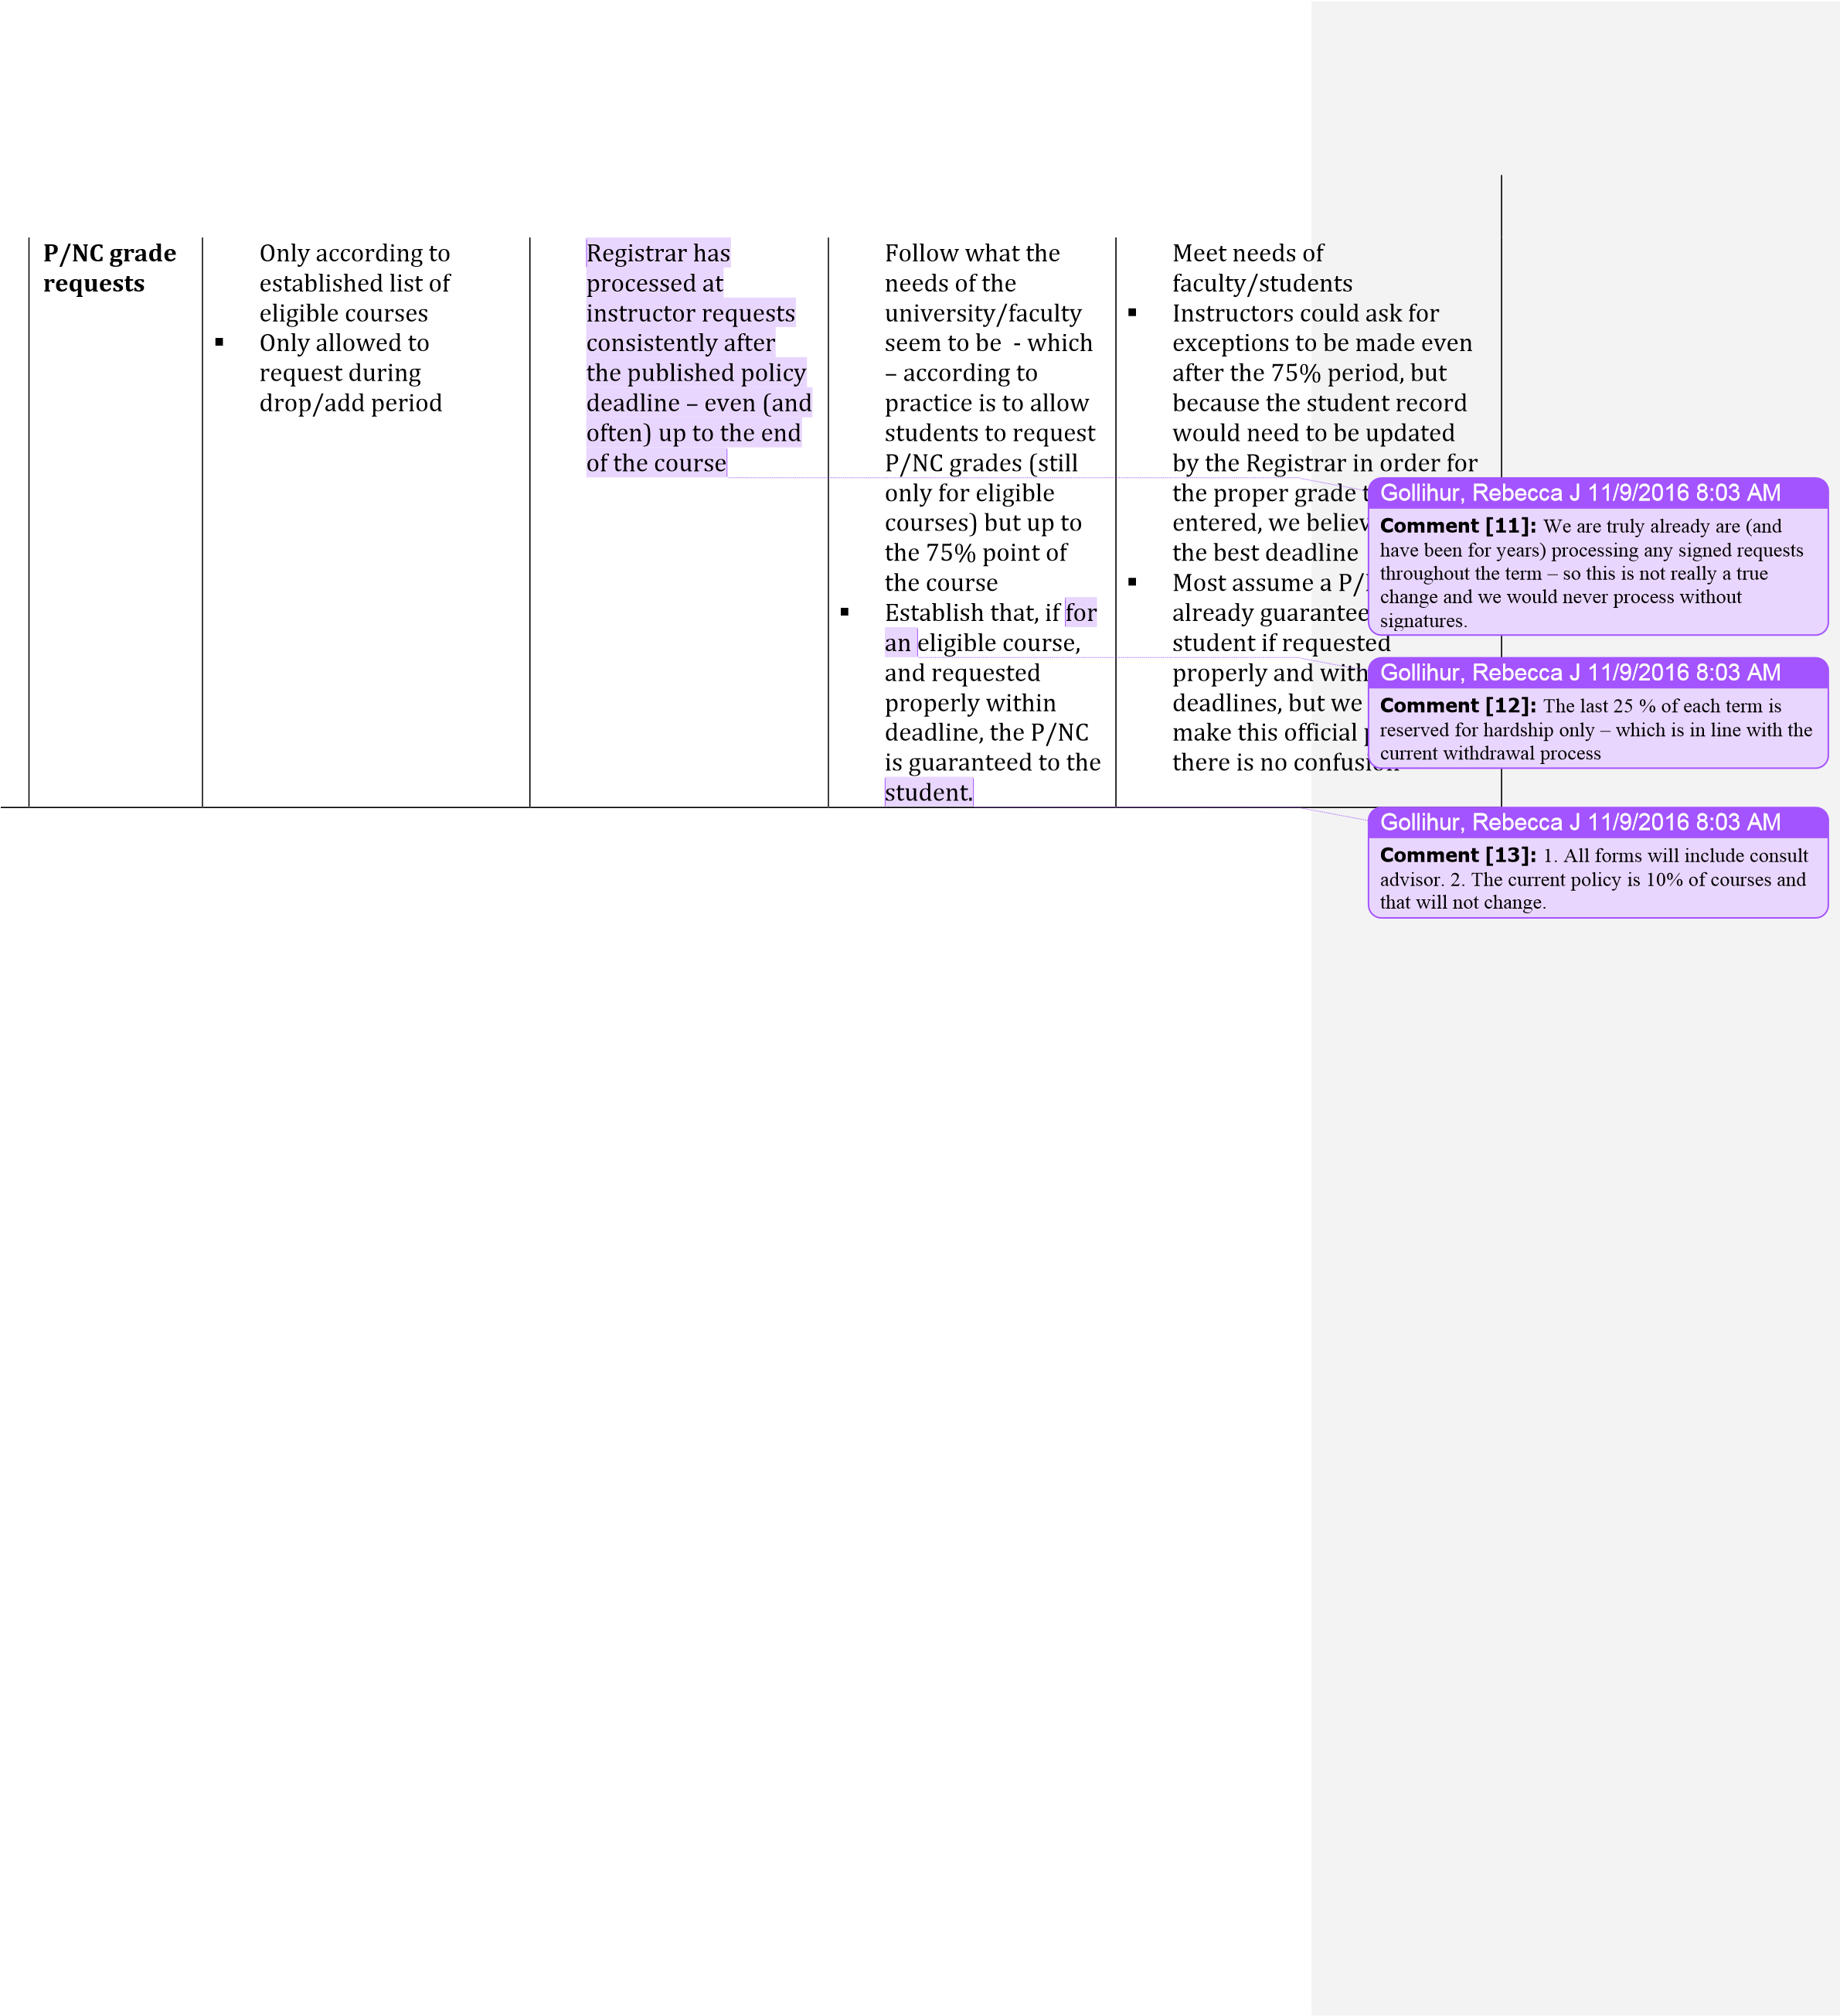

Curriculum Senate Report February 3, 2017
Prepared January 27 by Erin Herberg Senate Curriculum Chair

The following proposals are being submitted for Senate Approval
Process Q: Quasicurriculum Proposals
Proposal # College Department Proposal
16-17- CCCA Rename the " Master of Arts in Public Relations" with "Master
_{PR/Advertising}
2.002 of Arts in Strategic Communication" 16-17- CCCA PR/Advertising Rename "Advertising Minor" with "Strategic Communication

2.006 Minor"
The department of Public Relations and Advertising requests the name change for these two programs as it better reflects the nature of the breadth of the courses in the curriculum and the applicability of the master’s degree and minor.

Process F: New Degree Proposals (*Approved by the Senate Curriculum Committee Pending Revisions)
Proposal # College Department Proposal

16-17-1.001* COB Management/Entrepreneurship MS in Organizational Leadership
A 30 credit hour master’s program designed to prepare students for organizational leadership positions in corporations and institutions and to become effective leaders.

16-17-3.018* CoED Ed Services and Leadership BA in Leadership & Social Innovation
A 36 credit hour interdisciplinary undergraduate program designed to prepare students to work in newer industries and with newer technologies, such as start-ups, foundations, non-profits, and community organizations, as well as business, government and policy institutions. Students will come to understand leadership and organizations, diversity, the design and evaluation of organizational initiatives, and grant acquisition and management. The program requires 18 credit hours of CoEd Leadership coursework and the selection of one 18-hour concentration. Concentrations for this program are drawn from existing CUGS and Minors across the university with the approval of the related programs/departments.

16-17-3.026* CoEd STEAM Ed MA Educational Technology (Graduate)
A 33 hour credit hour master’s program designed for students who desire to take leadership roles in their school organization. This program serves students who seek, or desire to continue, employment in P-12 schools and districts as teacher leaders or wish to pursue coordinator or supervisor positions. The program provide expertise in using technological tools and resources to support learning.

16-17-10.019* | Earth and  Environment | Environmental Science | BS in Environmental S | cience
A 68 credit hour undergraduate program designed to prepare students to become profess  (STEM  professionals). It includes an environmental science core, concentration, and restricted el are prepared to become Environmental scientists (industry or government agency) and ar in environmental science |  |  |  | ional environmental scientists  ectives. Students in this program  e prepared for graduate study
16-17-10.020* | Earth and  Environment | Environmental Science | BA in Environmental S | cience
A 39 credit hour undergraduate program designed for students who wish to become part These students would be prepared to join non-STEM Professions that require an understa the environment (STEM skills). It includes an environmental science core and free elective double majors, minors, or CUGS in related subject areas. |  |  |  | of the STEM-capable workforce. nding of the human impact on  s that provide options for
16-17-11.012* | Health  Professions | HES | BA in Health Promotio | n and Wellness
A 68 credit hour undergraduate program that replaces the B.A. in Health and Exercise Scie Health Promotion and Wellness with a stand-alone degree. |  |  |  | nce with a concentration in
13

