Important Information before Entering Requisitions

Payment Terms
Rowan, as a State University, is required to comply with the Prompt Payment Act which guarantees payment within 60 days. It should be noted that, Rowan’s internal policy is that we pay all invoices received within 30 days of receipt of the good/service or the invoice whenever possible.

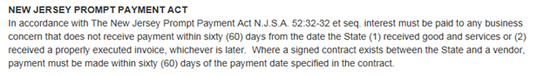

Bid Splitting
The Improper split of a purchase into multiple purchases in order to avoid triggering dollar thresholds that would require the End User to obtain additional documents.

Purchasing Thresholds
$0.01 - $3,329.99 | Quotes are encouraged but not required
$3,330.00 -$33,299.99 | Three (3) written quotes required
$33,300.00 | Contact Contracting & Procurement for assistance
Additional Thresholds
*$17,500.00 + | Require Ch.51/EO117 State compliance
*$25,000.00 + | Require System of Award Management (SAM) check
$33,300.00 + | Require second signature and review from Senior VP of Finance and Chief Financial Officer

In certain instances, three (3) quotes cannot be obtained, in which case Exceptions may be utilized. See below for list of State approved Exceptions.

18A:64-56 Exceptions to Public Advertised Bids

Selecting a Vendor

Search Banner using FTIIDEN to see if the Vendor already exists in the system.
Note: the search engine is case sensitive. You may use Wildcards (%) to search multiple ways. See below (are sample search is for Office Depot):
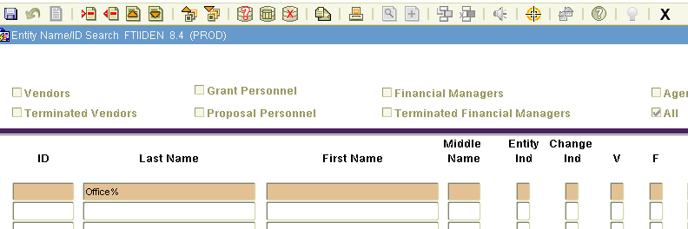
- Select All
- Vendor Name (%)
- Enter Query
- Vendors will populate
- Copy Banner ID

If the Vendor is not already in Banner, you will need to request a W9 and Business Registration Certificate (BRC) in order for C&P to create the Vendor. Once you have the required documents, forward to requisitions@rowan.edu and the Vendor will be created.

See Vendor Page for information on how to obtain the required forms.

Preferred Vendors

Awarded Vendors for Recurring Purchases/Services Please contact the originating department or a procurement representative prior to contacting the Vendor and/or entering a requisition.

Additional Requisition Requirements

IRT Related Purchases

Starting immediately, all software, computer hardware, and consulting purchases must be reviewed and approved by Information Resources & Technology to ensure they are aligned with institutional priorities and that IRT can support them once activated. Requests for review can be made by filling out the IT Review and Acquisition Form at Self Service Banner, under the Finance Section. This policy applies to all members of the Rowan community who seek to acquire IT Resources using University funds, including grant funds from contracts and/or transmittal forms between the University and external funding sources (public and private).

For additional instructions and information visit: IT Acquisition

Approvals made by IRT must be sent to requisitions@rowan.edu before the Office of Contracting & Procurement can process the request. All IRT orders, even if excluded from the IRT Acquisition Policy, require the corresponding quotes or invoices sent to requisitions@rowan.edu

Entertainment Form

All unit requests for the payment or reimbursement for entertainment or reception expenditures must comply with University policy on food/refreshments, and have a properly completed Entertainment Form submitted with your requisition.

Travel Form

All unit requests for the payment or reimbursement of travel expenditures must be accompanied by a
Accounts Payable Travel Forms.

Travel Agent Services are featured by the Accounts Payable Department. Please contact Miranda Salvatore, 856.256.4043 or salvatoremi@rowan.edu for more details.

Vehicle Purchase

All vehicle purchases require the President’s approval. The Vehicle Approval Form is utilized to obtain the appropriate signatures and approvals.

Leases

When entering a requisition for a leased property, you should always use a Standing Order for the entire fiscal year. Submit the lease with your backup documentation and use Account Code 7311.
- Standing Order
- Submit Lease
- Use Account Code 7311
- Leased property address in doc text

Sole Source Exception

It is the policy of Rowan University to procure all materials, equipment, supplies, and services through competitive means. However, there exists a category of expenditure whereby such open bidding is not possible due to the product or service being available from only one source. In those instances, the Procurement Department upon appropriate justification, will act with all due diligence to obtain the product or service at the best possible price to the University.

The Sole Source Justification Form must be fully executed, with at least one category completed, in order to approve your purchase. Please forward your completed approval form along with additional supporting documents, i.e., contracts, quotes, specifications, to contracts@rowan.edu.

A Contracting & Procurement team member will notify you once your Sole Source request has been approved.

Furniture

All furniture purchases require approval from Facilities, Planning & Construction. Please contact Tony Kula at kula@rowan.edu ext. 4948.

Requisitions

How to Enter a Requisition in Banner
- Commodity Code List
- Account Codes

How to Create a Standing Order
Standing Orders (SO) are used primarily when your purchase is recurring. If you receive monthly invoices or know that you will continuously purchase from the same vendor, e.g., Office Max, you will want to use a SO and pay against one purchase order for the fiscal year.

When creating your requisition, type the “Standing” or “SO” in Comments. Shown Below:
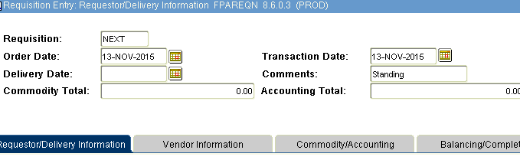
Submitting Supporting Documentation
- Send to requisitions@rowan.edu
- Annotate requisition # in subject line
- Attach quote, proposal, invoice, appropriate approvals, required forms, etc.
  - Note: Any submitted documentation that has a signature line and/ or terms and conditions will be stopped. These are considered “contracts” and will go through the Contract Approval Process before your requisition is converted. To avoid delay, please send your supporting documentation to contracts@rowan.edu. See Contracts for additional instructions.

How to Request a Change Order
Requests to modify your purchase orders should be sent to changeorders@rowan.edu with the following information:
- Purchase Order #
- Original Amount
- Amount of Change
- New Total
- Supporting Documentation
- Note: If your change is for something other than price increases/decreases, please ensure your email clearly addresses your need.

How & When to Request a PO Closure

