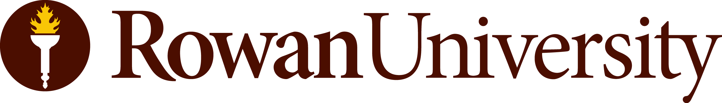
ACKNOWLEDGEMENT OF RISK AND RELEASE

Acknowledgment and Release Agreement for Rowan Students
Participating in Activities (on or off Campus), Field Trips and Similar Activities

By signing below, I acknowledge that as a Rowan University (“Rowan”) student, while I am participating in [IDENTIFY EVENT], being held [IDENTIFY DATES; SEMESTER; LOCATION; ETC] (“Activity”), I am expected to conduct myself in accordance with Rowan policies. I understand that the Rowan Student Code of Conduct applies to my conduct during these activities.

I agree to conduct myself in conformance with Rowan policies and agree to be under the general authority and supervision of the club/class sponsor/faculty member or other Rowan approved and/or designated supervisor. I understand that the class/club sponsor/faculty member, designated supervisor and Rowan are not responsible for my negligence or misconduct or for any losses, damages and/or injuries I may suffer while participating in the Activity.
I assume all risks of injury, illness, or loss of personal property resulting from my participation in the Activity, which may or may not include transportation by Rowan University. This Acknowledgment of Risk and Release includes, without limitation, all injuries which may occur as a result of my participation in the Activity.

If the Activity is in person, I acknowledge that I have been advised of the risks associated with my participation in the Activity, during times of increased health concerns and risks of communicable diseases. Specifically, I understand that although Rowan has instituted policies and procedures intended to minimize the risk of the spreading of contagious diseases, including COVID-19, such risks are unavoidable in certain in person activities and settings. While this Acknowledgment of Risk and Release is not limited to COVID-19 and addresses the risk of spread of all infectious diseases and other risks of participation in the Activity, the novel coronavirus, COVID-19, is a highly infectious, life-threatening disease declared by the World Health Organization to be a global pandemic. COVID-19’s highly contagious nature means that contact with others can lead to infection. Additionally, individuals who may have been infected with COVID-19 may be asymptomatic for a period of time, or may never become symptomatic at all. Because of its highly contagious and sometimes “hidden” nature, it may be difficult to control the spread of COVID-19 or to determine whether, where, or how a specific individual may have been exposed to the disease.

Aware of the foregoing, I am voluntarily electing to participate in the Activity. I understand that the University has put in place new safety rules and precautions in order to mitigate the spread of COVID-19, which rules and precautions may be updated at any time. While acknowledging that these rules and precautions may or may not be effective in mitigating the spread of COVID-19, I agree to comply with such rules and precautions. I understand that failing to comply with these rules and precautions is a violation of the University’s policies relating to public health and that failing to comply could subject me to removal from the Activity. I understand that I will be provided with information about the public health policies but that I may be required to complete a health assessment prior to participation in the Activity, participate in contact tracing investigations, follow infection prevention strategies, including social distancing and facial covering where appropriate, and other actions necessary to prevent infection.

In full awareness of the above and in consideration for my participation in the Activity, to the extent permitted by law and not inconsistent with the New Jersey Tort Claims Act, I do hereby waive, release and discharge any and all claims for death, illness, injury or damage (including the spread of infectious diseases) against Rowan University, and all affiliates, employees, officers, agents, representatives, successors, or assigns, relating to the Activity, which I may have as a result of my election to participate in the Activity. I understand and agree that this waiver shall release Rowan University from any claims based on the actions or omissions of the University, its employees, officers, agents, representatives, successors or assigns, whether any infection, illness or harm occurs before, during, or after my participation in the Activity. I further agree that this release and agreement not to sue will be binding on my heirs and successors.

I further agree that if a claim is filed by a third party in connection with any of my conduct or behavior while engaged in these activities, I will indemnify and hold harmless Rowan University, its employees and representatives against any such claims, including attorneys’ fees incurred by Rowan University in defending such claims.

I hereby also consent to and authorize the use and reproduction by Rowan, or anyone authorized by Rowan, of any and all photographs, videography, and audio recordings that have been taken of me during the activities, without compensation to me or my assignees.

If any portion of this Release from liability shall be deemed by a Court of competent jurisdiction to be invalid, then the remainder of this Release from liability shall remain in full force and effect and the offending provision or provisions will be severed herefrom. By signing this Release, I acknowledge that I understand its content and that this Release cannot be modified orally.

I acknowledge that I have carefully read this document and fully understand that it is a release of liability and that I am at least 18 years of age and competent to sign this document.

____________________________________ ____________________________________
Signature Print Name Date

_____________________________________ ____________________________________
Signature of Legal Guardian (if under 18) Print Name Date

